Crop Ecology. Answers to exercises for “Lintul-1: Potential crop growth”

Brazil, Tuesday January 19, 2010

1) Which weather variables are important for calculating potential crop growth?

To calculate potential crop growth only temperature and radiation are needed from the weather data.

2) In which type of year is the yield highest.

The yield is highest in the wet year (1975), for both sowing dates.

3) Explain the possible causes why in that type of year the yield is highest, using the information of both figures.

A higher yield may be obtained if there is a lower average temperature causing a slower development and a higher LAI (see the figure in the exercise). Furthermore, yield may be enhanced by a higher cumulative radiation. Both these aspects occur in the wet year, see the three figures below:

Plots between the days of the year that crop grows (between days 150-300) and temperature, radiation and cumulative rain.

Temperature sum as a function of time shows that the wet year is lowest.  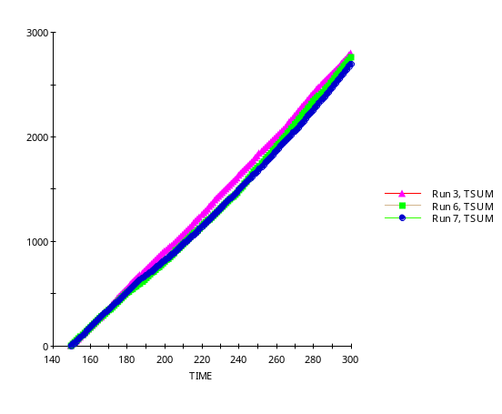 | Cumulative radiation as a function of time shows that the wet year is similar to the average.  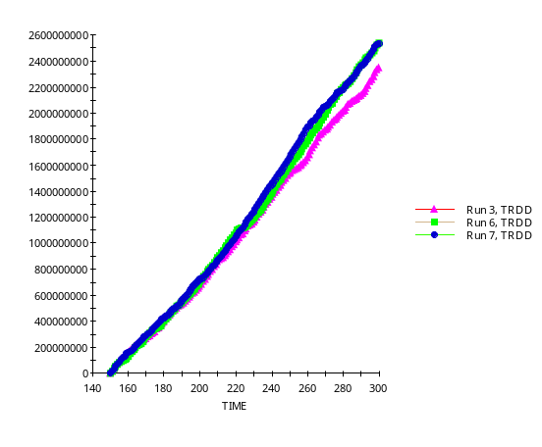
Cumulative rain as a function of time shows that the wet year is wettest until the end of the year, where the growing season is about over.  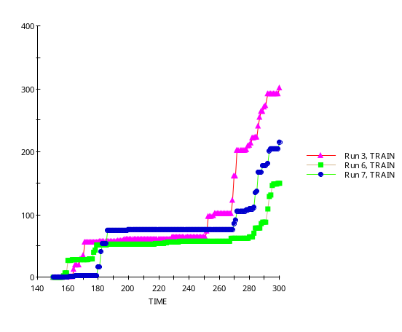 | Run 3: dry year 1971  Run 6: average year 1974  Run 7: wet year 1975  Note: You probably think that the legend of the TRAIN is wrong, but the dry, average and wet years were selected by looking to the year as a whole. This shows that it is better to look at the seasonal values, because those are the ones annual crops experience. For perennials, however, one can better consider the year as a whole.  In the case of the Netherlands the dry, average and wet years also hold for the seasons (see page 4).

4) Which sowing date would you recommend to a farmer if these figures were confirmed by experimental data?

If these figures would be confirmed by experimental data, we would recommend the later sowing date, because in all three years the LAI is highest, which should result in more yield, as is indeed shown by the figures in the exercise.

5) What are the units of K, SLA, RGRL, DOYEM and LUE. Include in these units also the biological or physical entity. For example not only g, but g biomass, not g/g but, for instance, g water / g soil (soil moisture content on a weight basis).

K : m² of soil m^{–2} of leaf, thus the inverse of the LAI, because it appears in the
power of the e-function that needs to be dimensionless;
SLA : m² of leaf g^{–1} leaf;
RGRL : (˚C d)^{–1};
DOYEM : d;
LUE : g of biomass MJ^{–1} of visible light (PAR), usually reported as g MJ^{–1}.

6) Which parameter change increases final yield most? Distinguish between the parameters affecting the cumulative light interception of the crop and the light utilization. Explain the reasons for this.

For the parameters that affect the cumulative light interception by the crop:
∆K +10% affects WSOTHA most, except in the average year where a change in DOYEM showed more yield;
70% │
∆SLA +10% less important, about 0.45/0.64 x 100% = 76% │ of K
75% │
∆RGRL +10% is comparable with SLA. RGRL is important in the early growth and closure of the crop;

For the parameter that affects the efficiency by which light is utilized:
∆LUE +10%. In all three years LUE + 10% has more effect than K.
Explanation:
LUE has more impact than K, because if K > → less light in lower leave layers so less effective capture of light. But if LUE +10%, the light at every depth in the crop is more efficiently used, see figure, resulting in a better performance. Mathematically, in the equation GTOTAL = LUE x PAR x (1 – e^{– (K x LAI)}), a change in K, that occurs in the power of e, has less effect than a change in LUE, because the latter is linearly present in the equation.
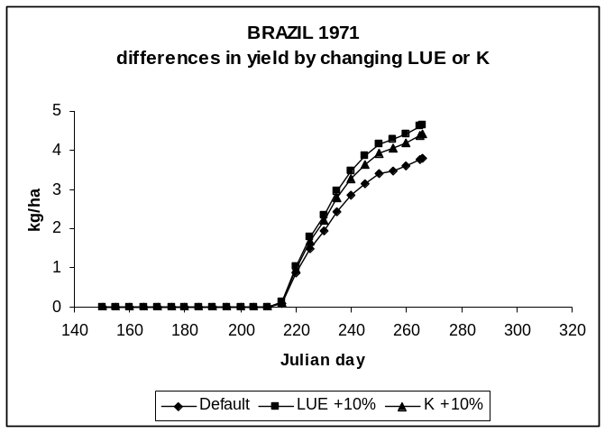

7) Which month gives the highest potential yield?

For 1971 → 1972 WSOTHA is largest when starting is in December (or Jan) (dry year).
For 1974 → 1975 WSOTHA is largest when starting is in July (average year).

8) Comment on the assumption that emergence and growth takes place throughout the whole of the year.

It is not reasonable to assume that emergence can take place throughout the year, because in reality spring wheat will die at low (especially below zero) winter temperatures. For the years we used for Brazil the lowest temperatures were 3 ˚C, so not very low. Remember, a model should only be used within the range of its validity, and the user should assess that validity range.

We also used spring wheat parameters from the Netherlands. For Brazil there will be varieties that are better adapted to that environment, however.

P.A. Leffelaar, Wageningen, 3 December 2009

Crop Ecology. Answers to exercises for “Lintul-1: Potential crop growth”

Netherlands, Tuesday January 19, 2010

1) Which weather variables are important for calculating potential crop growth?

To calculate potential crop growth only temperature and radiation are needed from the weather data.

2) In which type of year is the yield highest.

The yield is highest in the dry year (1976), for both sowing dates.

3) Explain the possible causes why in that type of year the yield is highest, using the information of both figures.

A higher yield may be obtained if there is a lower average temperature causing a slower development and a higher LAI. This is not the case in the Netherlands, however (see the figure in the exercise). But a higher cumulative radiation may stimulate crop growth as well. The latter aspects occurs in the dry year, see the three figures below:

Plots between the days of the year that crop grows (between days 60-240) and temperature, radiation and cumulative rain.

Temperature sum as a function of time shows that the years are very similar.  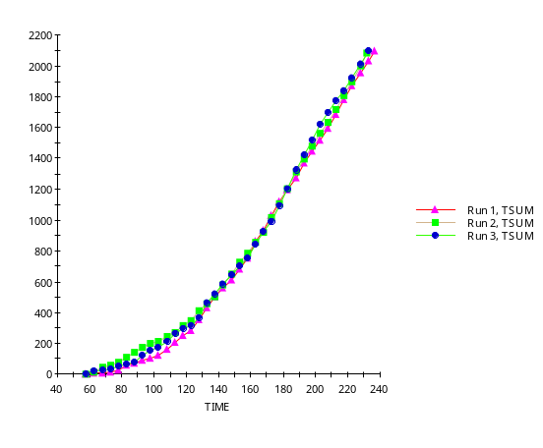 | Cumulative radiation as a function of time shows that the dry year is highest.  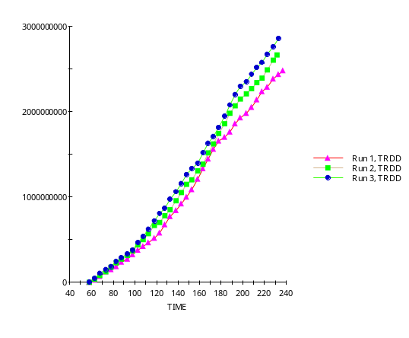
Cumulative rain as a function of time shows that the wet year is very wet as compared to the dry year.  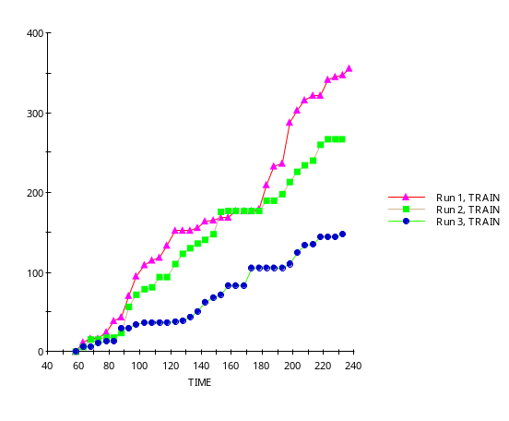 | Run 1: wet year 1970  Run 2: average year 1973  Run 3: dry year 1976  Note: For the Netherlands the dry, average and wet years also hold for the seasons. This is not always the case. For example for the Brazilian case the seasonal values for the dry, average and wet years are different from the yearly values (see page 1).
4) Which sowing date would you recommend to a farmer if these figures were confirmed by experimental data?

If these figures would be confirmed by experimental data, we would recommend the earlier sowing date, because there is a higher yield there, see the figure in the exercise. However, it is not consistent throughout the years, so the recommendation would be weak.

5) What are the units of K, SLA, RGRL, DOYEM and LUE. Include in these units also the biological or physical entity. For example not only g, but g biomass, not g/g but, for instance, g water / g soil (soil moisture content on a weight basis).

K : m² of soil m^{–2} of leaf, thus the inverse of the LAI, because it appears in the
power of the e-function that needs to be dimensionless;
SLA : m² of leaf g^{–1} leaf;
RGRL : (˚C d)^{–1};
DOYEM : d;
LUE : g of biomass MJ^{–1} of visible light (PAR), usually reported as g MJ^{–1}.

6) Which parameter change increases final yield most? Distinguish between the parameters affecting the cumulative light interception of the crop and the light utilization. Explain the reasons for this.

For the parameters that affect the cumulative light interception by the crop:
∆K +10% affects WSOTHA most, and in all cases;
53% │
∆SLA +10% less important, about 0.26/0.49 x 100% = 47% │ of K
49% │
∆RGRL +10% is comparable with SLA. RGRL is important in the early growth and closure of a crop;

For the parameter that affects the efficiency by which light is utilized:
∆LUE +10%. In all three years LUE + 10% has about twice the effect compared to K. Explanation:
LUE has more impact than K, because if K > → less light in lower leave layers so less effective capture of light. But if LUE +10%, the light at every depth in the crop is more efficiently used, see figure, resulting in a better performance. Mathematically, in the equation GTOTAL = LUE x PAR x (1 – e^{– (K x LAI)}), a change in K, that occurs in the power of e, has less effect than a change in LUE, because the latter is linearly present in the equation.

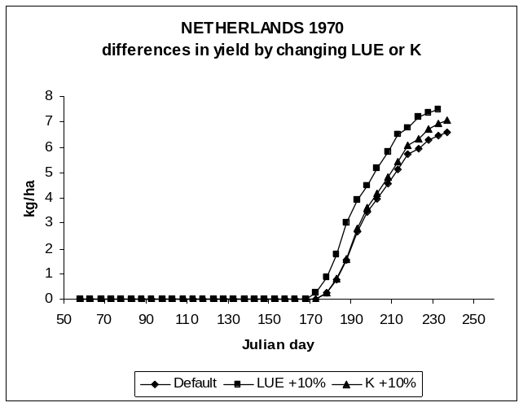

7) Which month gives the highest potential yield?

For 1970 → 1971 (wet year) start in January or April highest yield.
For 1973 → 1974 (average year) January highest yield.

8) Comment on the assumption that emergence and growth takes place throughout the whole of the year.

It is not reasonable to assume that emergence can take place throughout the year, because in reality spring wheat will die at low (especially below zero) winter temperatures. For the years we used for the Netherlands the lowest temperatures were below –10 ˚C, so really too low. Remember, a model should only be used within the range of its validity, and the user should assess that validity range.

P.A. Leffelaar, Wageningen, 3 December 2009

